 | ಬಿ.ಎಂ.ಎಸ್. ತಾಂತ್ರಿಕ ಮತ್ತು ವ್ಯವಸ್ಥಾಪನಾ ಮಹಾವಿದ್ಯಾಲಯ  BMS Institute of Technology and Management  (Autonomous Institution Under VTU, Belagavi)  Avalahalli, Doddaballapur Main Road, Yelahanka, Bengaluru - 560119  DEPARTMENT OF ARTIFICIAL INTELLIGENCE AND MACHINE LEARNING | 

SOCIETAL PROJECT
Course Code: 1BSOP308 | 2025 Scheme | III Semester
PROJECT REPORT ON
“BloodConnect: An AI-Assisted Emergency Blood Donor Coordination Platform for Bengaluru”
Submitted in partial fulfilment of the requirements for the award of the degree of
BACHELOR OF ENGINEERING
IN
ARTIFICIAL INTELLIGENCE AND MACHINE LEARNING
Submitted by
Sl. No. | Student Name | USN
1 | MITHUN GOWDA M | 26UG1BYAI401-T
2 | RANJEETHA | 26UG1BYAI410-T
3 | RAKSHITHA R | 26UG1BYAI414-T
4 | NIKHIL V | 26UG1BYAI416-T
Under the guidance of
[NAME OF PROJECT GUIDE]
[DESIGNATION] | Department of AI & ML, BMSIT&M
Section: ______  14 | Team No.: ______ | Project Domain: Healthcare Informatics
ACADEMIC YEAR 2026-27


CERTIFICATE
This is to certify that the Societal Project (1BSOP308) entitled “BloodConnect: An AI-Assisted Emergency Blood Donor Coordination Platform for Bengaluru” is a bona fide work carried out by [Student Name 1 (USN)], [Student Name 2 (USN)], [Student Name 3 (USN)] and [Student Name 4 (USN)] of III Semester B.E. (Artificial Intelligence and Machine Learning), BMS Institute of Technology and Management, during the Academic Year 2026-27. The project has been completed under the guidance of [Name of Project Guide], [Designation], Department of Artificial Intelligence and Machine Learning. It is further certified that the corrections and suggestions made during the internal reviews have been incorporated and that this report satisfies the academic requirements prescribed for Societal Project under the 2025 Scheme.
_________________________  Project Guide  Department of AI & ML | ________________________  Project Coordinator  Department of AI & ML | _________________________  HoD  Department of AI & ML
VIVA-VOCE
Sl. No. | Name of Panel Examiner | Signature with Date
1
2

DEPARTMENT VISION AND MISSION
VISION
To emerge as a leading department in AI and ML by preparing skilled, responsible, and eco-friendly professionals who use technology to improve society.
MISSION
M1. To equip students with in-depth knowledge in Artificial Intelligence and Machine Learning, built upon a robust foundation in Computer Science and Engineering through industry-focused curriculum with practical learning.
M2. To encourage research and innovation through industry partnerships and sustainable technology practices.
M3. To inspire students toward ethical leadership and entrepreneurship through innovative and collaborative student-led activities.


PROGRAM EDUCATIONAL OBJECTIVES (PEOs) AND PROGRAM SPECIFIC OUTCOMES (PSOs)
Program Educational Objectives (PEOs)
PEO1 | Graduates will thrive as IT professionals, applying AI and ML to build creative and lasting solutions.
PEO2 | Graduates will pursue further studies, research, and entrepreneurship, keeping up with technological advancements in various fields.
PEO3 | Graduates will demonstrate ethics, integrity, leadership, teamwork, and a dedication to continuous learning in their careers.
Program Specific Outcomes (PSOs)
PSO1 | Apply foundational knowledge of Computer Science along with AI and ML techniques to design effective, real-world solutions across diverse application domains.
PSO2 | Develop AI-driven innovations with a commitment to ethics, social responsibility, and sustainability.

SUSTAINABLE DEVELOPMENT GOALS (SDGs) MAPPING
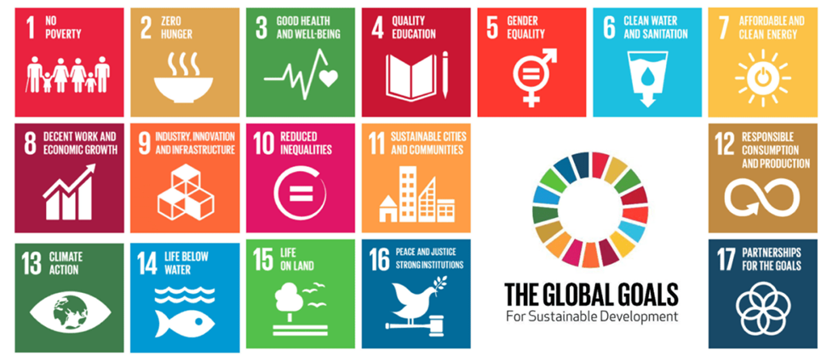
Map only the SDG(s) that have a direct and defensible relationship with the project. State how the project contributes and identify the evidence or indicator that will be used to demonstrate the contribution.
SDG No. | SDG Goal | Project Linkage | Evidence / Indicator
3 | Good Health and Well-being | Helps a family or a ward staff member start the search for a compatible voluntary donor, and see hospital and blood-centre information, without depending only on personal phone contacts. | Working match by ABO/Rh and distance; hospital and blood-centre screens; eligibility screen that blocks an under-age or recently donated profile; clinical disclaimer on the result.
9 | Industry, Innovation and Infrastructure | Uses an ordinary browser as the coordination layer so the first version does not need a separate installed application for each blood centre. | Prototype pages for request, match, directory and shortage view; service tests for compatibility and ordering.
10 | Reduced Inequalities | A public directory and a short request path are usable by a person who does not already know donors inside a hospital network. | Directory pages that can be opened without first building a private contact list; survey item on how blood was actually found.

ABSTRACT
Arranging blood during an emergency in Bengaluru is still largely a manual search. Families and hospital staff call known donors, post in messaging groups, and enquire at more than one blood centre while the patient is waiting. Rare groups and a recent donation that makes a willing person ineligible make that search slower. This project presents BloodConnect, a student-built web prototype that records an emergency need, keeps only red-cell ABO and Rh compatible donors, and ranks them by distance from the request when coordinates are available. The same prototype lists hospitals and blood centres used in the Bengaluru setting, applies a preliminary donor screen for age, weight, haemoglobin and a 90-day interval, and shows which groups are short when illustrated stock is compared with a projected demand. A Spring Boot service covers registration, login, one-time password verification and request handling. Checks on the compatibility table, distance ordering and eligibility rules were used for validation, together with a 17-item public survey form. BloodConnect does not cross-match blood and does not replace a licensed blood bank. Its purpose is a clearer first search for a voluntary donor or a centre that may have stock.

ACKNOWLEDGEMENT
We express our sincere gratitude to Dr. Sanjay H A, Principal, BMS Institute of Technology and Management, for providing the academic environment and institutional support required to undertake this Societal Project. We thank Dr. Anupama H S, Head of the Department of Artificial Intelligence and Machine Learning, for her encouragement and support throughout the project.
We are deeply grateful to our Project Guide, [Name of Project Guide], [Designation], Department of AI & ML, for the guidance, technical inputs and constructive feedback provided during the planning, execution and documentation of the project. We also thank the Project Coordinator and the review panel members for their suggestions during the project reviews.
We acknowledge the support of the stakeholders/community/organisation associated with this project for their time, observations, feedback and cooperation. We also thank the faculty and staff of the Department of AI & ML, our parents and friends for their encouragement and support.
By,
MITHUN GOWDA M
RANJEETHA
RAKSHITHA R
NIKHIL V

DECLARATION
We hereby declare that the Societal Project (1BSOP308) titled “BloodConnect: An AI-Assisted Emergency Blood Donor Coordination Platform for Bengaluru” is an original record of project work carried out by us during the Academic Year 2026-27 as part of the B.E. programme in Artificial Intelligence and Machine Learning at BMS Institute of Technology and Management. The work has been completed under the guidance of [Name of Project Guide], [Designation], Department of AI & ML.
We further declare that the report appropriately acknowledges the sources, data, tools and external contributions used in the project, and that the work has not been submitted elsewhere for the award of any degree, diploma or equivalent academic qualification.
Student Declaration and Signatures
Sl. No. | Photo | Student Name | USN | Signature
1 | [Photo] | MITHUN GOWDA M | 26UG1BYAI401-T
2 | [Photo] | RANJEETHA | 26UG1BYAI401-T
3 | [Photo] | RAKSHITHA R | 26UG1BYAI401-T
4 | [Photo] | NIKHIL V | 26UG1BYAI401-T

TABLE OF CONTENTS
Use this structure as the standard report flow. Sections marked “as applicable” may be adapted to the project type without removing the core societal-problem, methodology, validation, ethics and impact components.
Section | Title | Page No.
Chapter 1 | Introduction and Societal Context | 14
1.1 | Background and Need | 14
1.2 | Stakeholders / Target Community | 15
1.3 | Problem Identification and Evidence | 16
1.4 | Problem Statement | 18
1.5 | Objectives | 18
1.6 | Scope, Constraints and Assumptions | 19
Chapter 2 | Literature Survey and Gap Analysis | 20
2.1 | Literature Survey | 20
2.2 | Existing System / Current Practice | 21
2.3 | Comparative Analysis | 22
2.4 | Identified Gap and Project Motivation | 23
Chapter 3 | Proposed Solution and Methodology | 24
3.1 | Proposed Engineering Response | 24
3.2 | System Architecture / Conceptual Framework | 25
3.3 | Methodology / Project Workflow | 26

TABLE OF CONTENTS (CONTINUED)
Section | Title | Page No.
3.4 | Requirements: Hardware / Software / Materials / Data (as applicable) | 27
3.5 | Ethical, Safety and Sustainability Considerations | 28
Chapter 4 | Implementation / Prototype / Field Execution | 30
4.1 | Design and Development | 30
4.2 | Data Collection / Processing / Prototype Development (as applicable) | 34
4.3 | Tools, Technologies and Resources | 36
4.4 | Implementation Evidence and Progress | 37
Chapter 5 | Testing, Validation and Results | 38
5.1 | Validation / Evaluation Plan | 38
5.2 | Test Cases / Evaluation Criteria / Field Validation | 38
5.3 | Results and Analysis | 40
5.4 | Stakeholder / User Feedback | 41
5.5 | Limitations | 42
Chapter 6 | Societal Impact, Sustainability and SDG Contribution | 44
6.1 | Societal Impact / Beneficiary Outcomes | 44
6.2 | SDG Mapping and Evidence | 44
6.3 | Feasibility, Accessibility, Cost and Sustainability | 45
Chapter 7 | Conclusion and Future Scope | 47
 | References | 49
 | Annexures | 50
LIST OF FIGURES
Figure No. | Figure Title | Page No.
Fig. 4.1 | Public home page of the BloodConnect portal | 30
Fig. 4.2 | Registration screen used for a donor or requester account | 31
Fig. 4.3 | Emergency blood request form | 32
Fig. 4.4 | Ranked list of compatible donors | 33
Fig. 4.5 | Hospital directory for the Bengaluru setting | 34
Fig. 4.6 | Blood-centre stock view | 35

LIST OF TABLES
Table No. | Table Title | Page No.
Table 1.1 | Stakeholders and what they need from the first search | 15
Table 2.1 | Current practice compared with the BloodConnect prototype | 22
Table 3.1 | Red-cell ABO and Rh compatibility used by the matcher | 27
Table 3.2 | Workflow from registration to a ranked list | 26
Table 3.3 | Software used to build and run the prototype | 28
Table 5.1 | Checks used to validate matching and eligibility | 38
Table 5.2 | Worked example of the priority score on imaginary donors | 40
Table 6.1 | SDG contribution and the evidence retained with the project | 44
Table A.1 | Items in the public survey instrument | 50

CHAPTER 1
INTRODUCTION AND SOCIETAL CONTEXT
1.1 Background and Need
Blood cannot be manufactured in a factory in the way a medicine tablet can. A unit that reaches a patient has to come from a healthy volunteer, be screened, and be issued by a licensed blood centre. The World Health Organization notes that a country generally needs voluntary donations from about one percent of its population if the basic requirement for blood is to be met, and that safety depends on a organised collection and testing system rather than on emergency family replacement alone [1]. In India, collection, testing, storage and issue are governed through licensed blood banks and through national guidance such as the standards published by the National AIDS Control Organization for blood banks and transfusion services [2]. The public stock view for many centres is the e-RaktKosh portal of the Ministry of Health and Family Welfare [3].
Those national systems answer an important question: which licensed centre may have a component. They do not, by themselves, stand beside a family in a Bengaluru ward and finish the next question, which is who among willing donors of a suitable group is near this hospital and is not inside the recovery interval after a previous donation. In practice that second question is still handled by phone calls and by forwarding messages. The delay is social as much as it is medical. The person searching is often a relative who is frightened, who may not know the difference between whole blood, red cells and platelets, and who may contact a donor who is willing but not eligible.
Bengaluru makes the distance part of the problem concrete. Hospitals and blood centres are spread across the city. A donor who is compatible on paper but is across a congested corridor is not the same resource as a compatible donor a few kilometres from the ward. A student project cannot remove traffic, and it cannot issue blood. It can reduce the confusion of the first hour by putting the request, the compatibility rule, the distance and the public centre list in one place.
BloodConnect is that place. It is a societal project prototype for III Semester, course 1BSOP308, built as a web application with a small prediction and screening layer. The word “AI-assisted” in the title is used in a narrow sense. The prototype scores a donor from distance, an exact group match, the time of day and a stored response rate, and it classifies the wording of a request into a priority band. These are transparent calculations. They are not a machine-learning model trained on hospital records, and they are not a clinical device.
1.2 Stakeholders and Target Community
The target setting is Bengaluru, with the surrounding Karnataka hospital context used where the directory already lists a centre. The people who feel the problem are not one group. A relative searching at night, a donor who wants to help but should not donate again too soon, a blood-centre staff member protecting stock, and a doctor who must not be given a false sense that a screen result is a cross-match, all have different needs. Table 1.1 records those needs so that later design choices can be checked against them.
Table 1.1 Stakeholders and what they need from the first search
Stakeholder | Situation | What the prototype should do | What it must not do
Patient’s family or friend | Needs a unit quickly and does not have a ready donor list | Take the group, units and place, and show a short ranked list | Promise that a listed person will arrive or is medically fit
Voluntary donor | Willing, but may be inside the recovery interval or below the weight or haemoglobin screen | Show eligibility in plain language and keep a 90-day interval | Pressure an ineligible person to donate
Hospital or ward staff | Repeats the same calls during trauma, surgery or a shortage | Offer a directory and a request that can be explained | Replace the hospital blood bank
Licensed blood centre | Holds tested stock and is legally responsible for issue | Point the user toward the centre and show an illustrated stock view | Issue, label or transport a unit
Student team and faculty reviewers | Must be able to demonstrate and defend the work | Keep rules, tests and limits written down | Present demonstration records as real patients

The community boundary is deliberate. BloodConnect is aimed at the search that happens before a blood centre takes over. Once a donor arrives, or once a centre is selected, screening, grouping, infectious-disease testing, cross-matching and phlebotomy belong to qualified staff. The about page of the prototype states that limit in the same words a user can read.
1.3 Problem Identification and Evidence
The problem was identified from three kinds of evidence that a student team can actually stand behind. The first is published practice. National and international guidance treats voluntary donation, donor selection and licensed testing as the safe path, and treats replacement donation under pressure as the weaker path [1], [2]. The existence of e-RaktKosh shows that stock visibility is already recognised as a public need [3]. The gap that remains is local coordination around one patient.
The second kind of evidence is the way people in the city already search. Messages asking for a named group, a hospital name and a phone number are a familiar sight in college, workplace and locality groups. That method has no compatibility check, no recovery-interval check and no ordering by distance. It also spreads a phone number far beyond the people who can actually donate. The project survey asks this directly: if blood was needed, how was it found, and how long did the first unit take. Those questions exist because the informal search is the baseline, not because the team claims a new city-wide statistic.
The third kind of evidence is the behaviour of the prototype itself on rules that can be calculated. An O negative recipient can receive red cells only from an O negative donor. An A positive recipient can receive from O negative, O positive, A negative and A positive donors, and must not be offered a B positive unit. A person under 18 years, under 45 kg, or inside 90 days of a previous whole-blood donation should not be presented as ready. These rules are not opinions. They are the checks the software either passes or fails, and they match the safety points a blood centre already explains to donors [2].
What this report does not treat as evidence is a measured drop in deaths or a measured drop in minutes across Bengaluru hospitals. No such trial was conducted. The honest claim is narrower: the search is fragmented, the failure modes are known, and a single explainable tool can remove some of those failure modes in a demonstration.
1.4 Problem Statement
During an emergency blood need in Bengaluru, families and staff lose time because donor discovery, red-cell compatibility, donor recovery interval and blood-centre contact information sit in separate conversations. The problem addressed by this project is to provide one web-based aid that accepts an emergency request, retains only compatible donors, ranks them using distance when a location is known, reminds the user that eligibility is preliminary, and shows hospital and blood-centre information, without presenting the result as a transfusion order.
1.5 Objectives
The objectives below are the ones the prototype and this report are built to meet.
• Describe the societal search problem around emergency blood in an urban Indian setting, with Bengaluru as the working context.
• Implement a request path that records blood group, component context, units and location.
• Apply a fixed red-cell ABO and Rh compatibility table and exclude donors who fail it.
• Rank remaining donors by distance using the Haversine formula, and by a visible priority score.
• Apply a preliminary eligibility screen for age, weight, a 90-day donation interval and, when a value is supplied, haemoglobin, plus a short list of deferral flags.
• Provide a directory of hospitals and blood centres and a shortage view that compares illustrated stock with projected demand.
• Support account registration and login on the service side, with one-time password verification before a new account can sign in.
• Validate the rules with unit checks and state clearly what the prototype does not do.
• Map the work to Sustainable Development Goals 3, 9 and 10 with evidence that can be shown.
1.6 Scope, Constraints and Assumptions
The scope is a working prototype and its explanation. Included are the public web pages, the matching and eligibility calculations, the Bengaluru-oriented directory data used for demonstration, the survey instrument, and the Spring Boot services for users, donor profiles, requests and matches. Excluded are connection to a live government stock feed, payment, ambulance dispatch as an operational service, drone transport, storage of real Aadhaar numbers, and any action that would legally constitute blood collection or issue.
Several constraints shaped the work. The team is at III Semester level, so the method had to stay explainable in a review. Real patient identifiers and real donor phone numbers were not collected into the report. Browser location works on a secure or local origin; if the user refuses location, a profile can still be stored but distance cannot be computed. The shortage figures shipped with the interface are scenario values for teaching the screen, not a forecast fitted to a hospital ledger.
The assumptions are stated so they can be challenged. The compatibility table used is the standard red-cell donor-to-recipient table, not the plasma table, unless the user is on the component view that shows plasma separately. A donor marked unavailable is not offered. Distance is straight-line distance on the Earth, adjusted in the browser demonstration by a road factor in some screens, and it is not a live traffic route from a paid map service. A listed donor in the demonstration file is a fictional profile for testing the screens.

CHAPTER 2
LITERATURE SURVEY AND GAP ANALYSIS
2.1 Literature Survey
The survey was limited to sources that change a design decision in this project: how blood need is understood, how a donor is selected, what a public stock portal already does, and which formula is appropriate for distance on a city map.
The World Health Organization fact sheet on blood safety and availability is the starting point for the societal claim. It connects availability to voluntary unpaid donation and connects safety to testing and to a managed supply, rather than to ad hoc replacement under stress [1]. That source does not describe a Bengaluru application. It does justify why a student tool should encourage a prepared voluntary donor and should refuse to bypass medical selection.
Indian practice is more specific about who may donate. The standards and donor-selection guidance used by blood banks under the National AIDS Control Organization and the National Blood Transfusion Council set expectations for age, weight, haemoglobin, interval between donations, and temporary or permanent deferral [2]. BloodConnect copies only a readable subset of those expectations into a preliminary screen: 18 to 65 years, at least 45 kg, haemoglobin of at least 12.5 g/dL when the value is entered, and 90 days since the last whole-blood donation. The screen text tells the user that the blood centre confirms the decision. Copying the entire guideline into code would pretend to be a medical examination.
e-RaktKosh is the relevant existing public system. It is the centralised blood-bank management portal of the Ministry of Health and Family Welfare and is meant to show stock and blood-bank information to the public [3]. Any new student system that hides this fact would be a poor literature review. BloodConnect is therefore described as a complement for the requester-to-donor step, not as a replacement for the national stock portal.
Distance ranking needs a published formula rather than a handmade approximation. The Haversine formula gives the great-circle distance between two latitudes and longitudes. Sinnott’s note in Sky and Telescope is a standard reference for the form used in navigation software [4]. The service implementation uses an Earth radius of 6371.0088 km and returns the distance rounded to one decimal place. Where the browser demonstration multiplies distance by a detour factor, that factor is an engineering allowance for urban roads, not a measurement of a particular day’s traffic.
The Sustainable Development Goals are used only where the link can be defended. Goal 3 concerns health, Goal 9 concerns resilient infrastructure and innovation, and Goal 10 concerns inequality of access [5]. Goals that would require an environmental life-cycle study or an employment study were not mapped.
2.2 Existing System and Current Practice
Four practices are visible around an emergency in the city. The first is the hospital blood bank. If stock of the required component exists inside the hospital, the family may never start an outside search. That path is the correct one and this project does not interfere with it. The second is a call or visit to another licensed centre, sometimes after checking e-RaktKosh or a centre website. The third is the personal network: relatives, colleagues, college groups and residents’ associations. The fourth is a social-media post that carries the patient name, hospital, group and a mobile number.
Each practice fails in a different way. The hospital bank fails closed when the group is rare or the component is platelets during a seasonal spike. The public portal can still leave the family to phone several centres because stock on a website is not the same as a confirmed cross-matched unit. The personal network fails when nobody nearby has the group, or when the person who answers last donated six weeks ago. The public post fails by privacy and by noise: ineligible volunteers arrive, and the patient’s contacts travel further than the family intended.
Commercial and voluntary apps exist in this space nationally. This report does not rank them. Many depend on a large registered base that a semester project does not have. The useful lesson from those products is the same lesson as from the messaging groups: a list without eligibility and without an explanation of why a person was ranked will not be trusted by a doctor, and a list that reveals phone numbers to every visitor will not be trusted by a donor.
2.3 Comparative Analysis
Table 2.1 compares the informal search and the national stock portal with the prototype on the points this project actually changes. The table is not a claim that BloodConnect performs better in a clinical trial.
Table 2.1 Current practice compared with the BloodConnect prototype
Point of comparison | Phone calls and messaging groups | e-RaktKosh and centre counters | BloodConnect prototype
Who it serves first | Whoever sees the message | A person looking for a blood bank | A requester with one patient and one place
Red-cell compatibility | Remembered by the caller, often wrongly | Handled inside the blood bank after contact | Fixed table applied before a donor is shown
Distance | Not ordered | The user chooses a centre | Haversine distance when both sides have coordinates
Donation interval | Rarely asked before the call | Checked at the centre | 90-day screen before the donor is treated as ready
Privacy of the donor | Phone number is forwarded widely | Centre contact is public by design | Match list in the service does not return the donor phone number
Stock | Rumours and repeated calls | Authorised stock reporting | Illustrated directory figures for demonstration, not a legal stock issue
Clinical authority | None | The licensed centre | None; disclaimer is part of the result

2.4 Identified Gap and Project Motivation
The gap is the missing link between a single emergency and a short, explained list of people who might help, plus the centres that should be called if a donor is not the right answer. e-RaktKosh covers centres. Messaging groups cover urgency and emotion. Neither applies a compatibility table, a recovery interval and a distance sort to the same request and then stops before pretending to be the blood bank.
The motivation for a department of Artificial Intelligence and Machine Learning is to use a small, inspectable scoring layer where it helps a social task, and to refuse a black-box claim where the data does not exist. Priority words in the request, distance decay and a shortage flag are useful if a reviewer can recompute them. A neural network trained on nothing would not be. That choice is itself part of the societal responsibility of the project.

CHAPTER 3
PROPOSED SOLUTION AND METHODOLOGY
3.1 Proposed Engineering Response
The response is a web prototype named BloodConnect. A requester enters the blood group needed, the number of units, the hospital or place, and a short description. The system keeps donors who are marked available and whose group can give red cells to that recipient. It computes distance where coordinates exist, assigns a priority score, and shows the list with the reason a donor is high or low. In parallel, the user can open a hospital directory and a blood-centre view. A separate screen classifies shortage from stock totals or from a prepared seven-day scenario.
The scoring used in the browser for donor response is a product of bounded factors. A base rate represents past willingness. Distance reduces the chance through an exponential decay, with a floor so a far donor is not scored as zero. A donor inside the 90-day interval is scored near the floor unless a demonstration override flag is set. An exact group match multiplies the score by a small bonus. Daytime hours score slightly higher than late night. The result is capped between 5 and 99 percent and is accompanied by short reasons such as “nearby” or “cooldown active”. The percentage is a ranking aid. It is not a probability learned from outcomes.
Request priority is also a score. A starting value is raised when the user marks the request critical or urgent, when the unit count is high, and when the free-text note contains words such as trauma, haemorrhage, surgery or ICU. The score maps to three bands: critical, high urgency and routine. This is keyword triage. It organises the queue. It does not diagnose the patient.
The service-side matcher is stricter and simpler, which is appropriate for a checked component. It loads available donors, filters them with the red-cell table, computes Haversine distance, and sorts by distance, then by priority score, then by name. The score awards 20 points when the donor is available, 50 points for an exact group or 30 points for a compatible but different group, and up to 30 points that fall as distance grows. Donor telephone numbers are not part of the match response.
3.2 System Architecture
The prototype has two cooperating parts. The part a visitor sees is a set of HTML pages with CSS and JavaScript. Those pages cover the home view, registration, login, the emergency form, match results, donor and hospital directories, the blood-centre stock view, a shortage radar, a dispatch tracking demonstration, and dashboards for a donor, a patient view and an administrator. Calculations that must stay visible in a review, including eligibility and the response score, run in the browser so a faculty member can relate a screen to a function.
The part that holds accounts is a Java Spring Boot application. It exposes registration, login, a current-user query, donor profile create and update, availability, nearby-donor search, blood-request create and status, match listing, and blood-bank stock read and update for an authorised role. Passwords are stored only as hashes. One-time passwords are stored only as hashes, expire, and are limited in attempts and resends. JSON Web Tokens carry the session. Local execution can use an in-memory database. A persistent deployment is specified against MySQL. The browser is expected to call the service with a bearer token after login.
This split matches the risk. A public demonstration of the screens can be shown from the pages. Identity, password handling and the authoritative compatibility filter sit on the service, where they can be tested without trusting the page. A future pilot would keep that split and would add a real stock source behind the blood-bank controller rather than behind a page file.
3.3 Methodology and Project Workflow
The work followed a straight student-project cycle: problem framing from published blood-safety practice, a written boundary that excludes clinical acts, a data model for user, donor profile and request, implementation of the compatibility and distance rules, screens for the Bengaluru scenario, tests on the rules, and a survey that can be taken to users without collecting a medical record. Table 3.2 is the runtime workflow a user sees, which is the part that has to be explained in a viva.
Table 3.2 Workflow from registration to a ranked list
Step | Who acts | What happens | Result
1 | New user | Registers with email, phone and role as donor or requester | Account stays unverified until both one-time passwords succeed
2 | Donor | Saves group, place, coordinates and availability | Profile can enter a later search only if marked available
3 | Requester | Submits group, units, hospital and note | Request is stored with an open status
4 | Matcher | Drops incompatible and unavailable donors | A shorter candidate list
5 | Matcher | Computes distance and priority | List ordered for the screen
6 | Requester | Reads reasons, directory and disclaimer | Chooses to contact a centre or follow the hospital process
7 | Requester or staff | Updates status when the need is met or dropped | Open, fulfilled or cancelled

The red-cell table implemented for that workflow is shown in Table 3.1. It is the table a reviewer can recompute by hand. Plasma compatibility is the reverse pattern and is shown in the component screen so that a user does not apply the red-cell rule to plasma by mistake. Platelet guidance on that screen prefers Rh compatibility. The service matcher used for tested requests applies the red-cell table.
Table 3.1 Red-cell ABO and Rh compatibility used by the matcher
Recipient | Donor groups accepted for red cells
O− | O−
O+ | O−, O+
A− | O−, A−
A+ | O−, O+, A−, A+
B− | O−, B−
B+ | O−, O+, B−, B+
AB− | O−, A−, B−, AB−
AB+ | O−, O+, A−, A+, B−, B+, AB−, AB+

3.4 Requirements
Hardware requirements are modest because the beneficiary side is a phone or a shared laptop browser. Development used a personal computer able to run a current Java development kit and a browser. No dedicated server, sensor or blood-storage device is part of the student build. A camera and a network connection are enough to demonstrate the pages.
Data requirements were handled so that the report does not depend on a hospital extract. Demonstration donors, centres and shortage scenarios are prepared records stored for the interface. They use fictional identities. The service tests build donor objects in memory. The survey asks for experience and opinion. The name field is optional, and the form states that it is not a blood request and not a medical record. A live pilot would need a data-sharing arrangement with a centre before any real stock number is shown as current.
Table 3.3 Software used to build and run the prototype
Layer | Software | Role in the project
Pages | HTML, CSS, JavaScript | Public workflow, directories, scores and eligibility text
Service | Java, Spring Boot | Accounts, profiles, requests, matching, stock API
Local data | H2, with MySQL defined for deployment | Accounts during a run; persistent option
Security pieces | Password hashing, hashed one-time passwords, JWT | Stop plaintext secrets and limit verification attempts
Checks | JUnit with parameterized compatibility cases | Lock the red-cell table and the sort order
Field instrument | Browser survey form | Collect experience without opening a patient file

3.5 Ethical, Safety and Sustainability Considerations
The main safety risk of a blood application is false confidence. A family may treat a green badge as permission to transfuse. Every eligibility result therefore carries the statement that the result is preliminary and that grouping, infectious-disease testing, cross-matching and the decision to draw blood belong to qualified staff at a licensed centre. The project does not store a transfusion order and does not print a compatibility label.
The second risk is harm to the donor. Calling a person who donated last month, a person below the weight screen, or a person who is pregnant is a direct harm. The 90-day interval, the age and weight gates, and the deferral flags for heart disease, insulin-dependent diabetes, active infection, recent tattoo or surgery, and pregnancy or lactation exist to refuse that call inside the prototype. They are a subset of donor-selection practice [2]. They are not a substitute for the questions a medical officer asks in private.
The third risk is privacy. An emergency post often publishes a patient’s condition and a donor’s phone number together. The service match response is defined not to include the donor phone number. Demonstration pages that show a masked identifier must not be filled with a real Aadhaar number. The survey allows the respondent to skip the name. This report does not reproduce individual answers.
Spam and panic requests are an ethical problem as well as a technical one, because they pull donors toward a fake hospital. The page-side check raises a flag when the unit count is implausible, the phone number is too short, or the hospital text looks like a test string. The flag sends the request to manual review in the story of the screen. It is a heuristic. A real deployment would add rate limits and an accountable administrator.
Sustainability here means whether the aid can continue without a large fee and without a fragile stack. The user needs a browser. The rules are small enough to maintain. The content that would rot is live stock, which is why live stock is not claimed. Electricity and hosting for a college demonstration are small beside the social cost of a wrong transfusion, so the design spends its care on refusal and explanation rather than on extra features.

CHAPTER 4
IMPLEMENTATION, PROTOTYPE AND FIELD EXECUTION
4.1 Design and Development
The interface was designed for a stressed reader. The home page states the purpose and offers a path into an emergency request, a donor search, hospitals and the shortage view. Type is large, the emergency action is visually distinct, and the pages reflow on a phone width. That choice follows the stakeholder in Table 1.1 who is not sitting at a desktop. Fig. 4.1 shows the public home page.

Fig. 4.1 Public home page of the BloodConnect portal
Registration collects the account and starts verification. On the service, a new user does not receive an access token until the email code and the phone code are both accepted. Codes are six digits, expire on a short timer, and further attempts are capped. Resend is cooled down so a script cannot flood a phone. The page in Fig. 4.2 is the registration step a visitor completes before any of that trust matters.
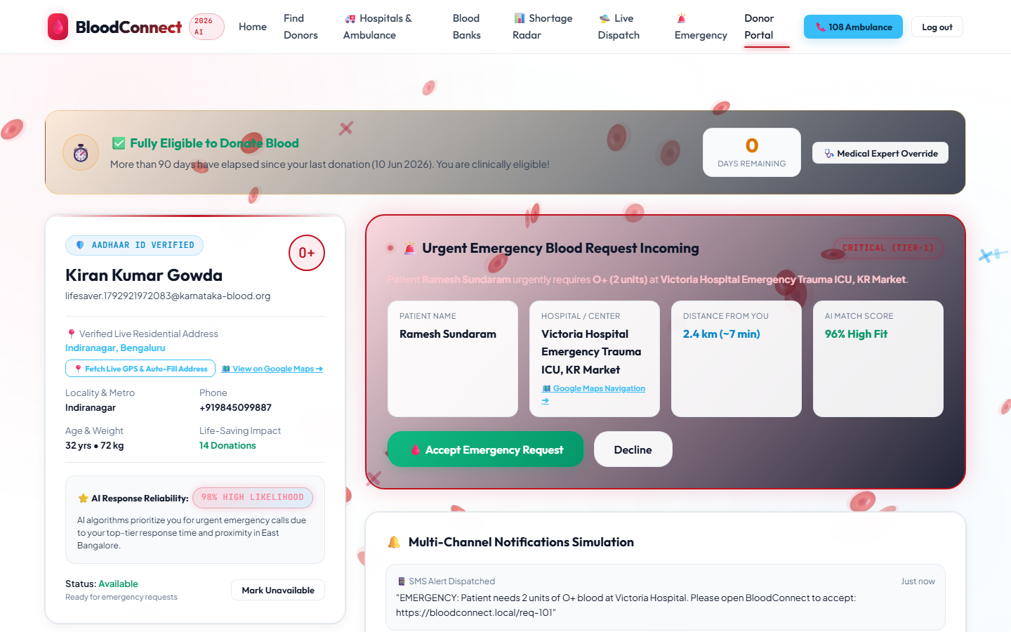
Fig. 4.2 Registration screen used for a donor or requester account
The emergency form is the core social action. It captures the group, the need and the place, and it can be filled with a prepared scenario so that a review does not depend on inventing a patient in the room. Fig. 4.3 shows that form. After submission, the match view in Fig. 4.4 lists candidates with the information needed to understand the order: group, distance and the reason for the rank. A user who expected a phone number on that service response will not find one. Contact, if it happens in a future pilot, has to be a conscious step with consent, not a side effect of opening a page.
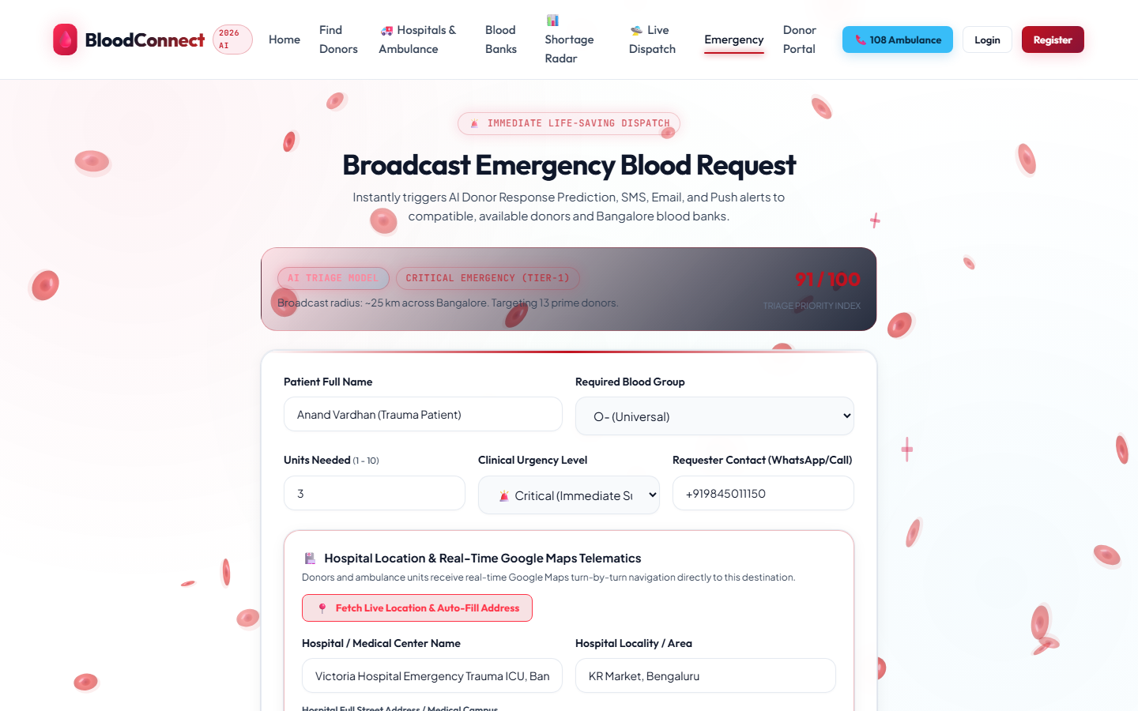
Fig. 4.3 Emergency blood request form
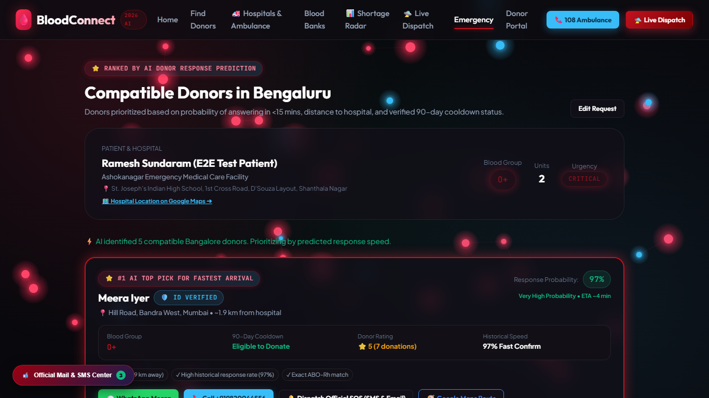
Fig. 4.4 Ranked list of compatible donors
4.2 Data, Processing and Prototype Behaviour
Directory content was prepared for Bengaluru and selected Karnataka centres so that the hospitals page and the blood-centre page are not empty shells. The hospital view collects name, area and a way to start navigation. The stock view groups units by ABO and Rh so a shortage of O negative is not hidden inside a single total. Figs. 4.5 and 4.6 show those two screens. Numbers on the stock screen are part of the demonstration data set. They should be read as interface evidence, not as this morning’s inventory of a named centre.
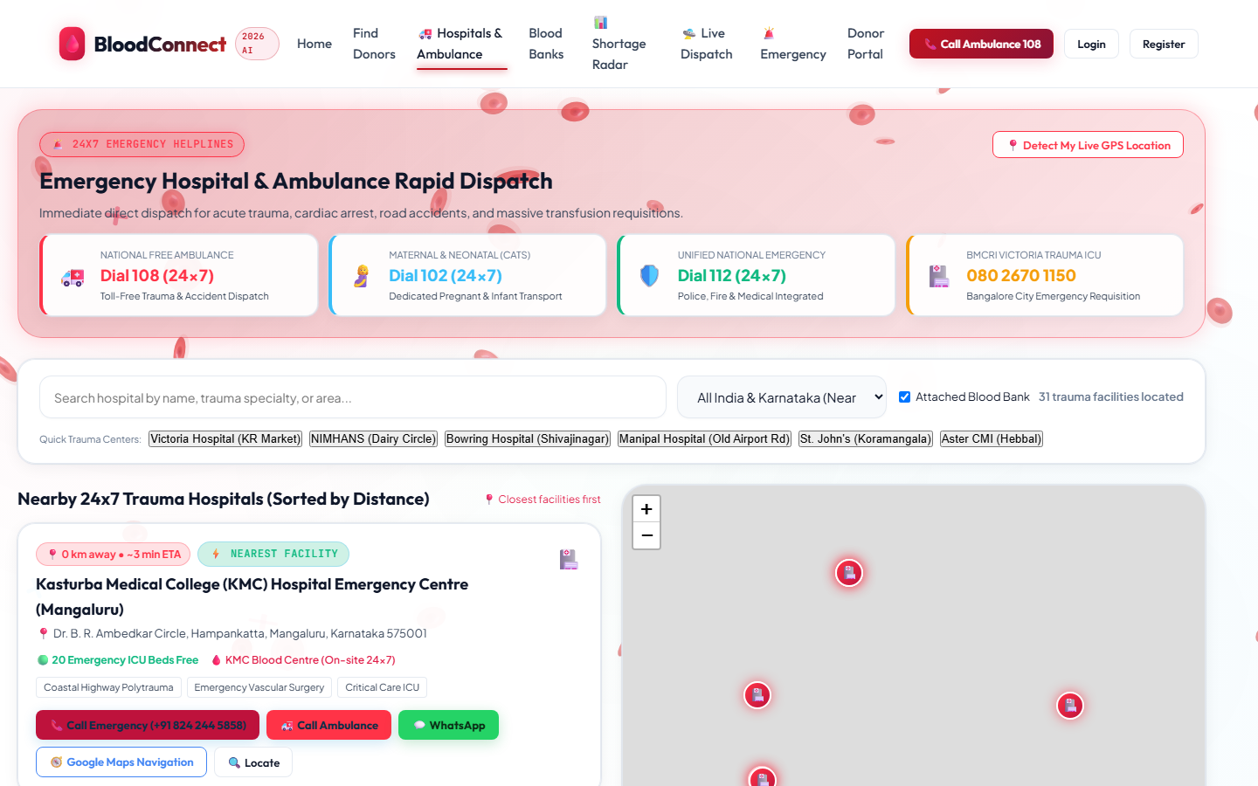
Fig. 4.5 Hospital directory for the Bengaluru setting
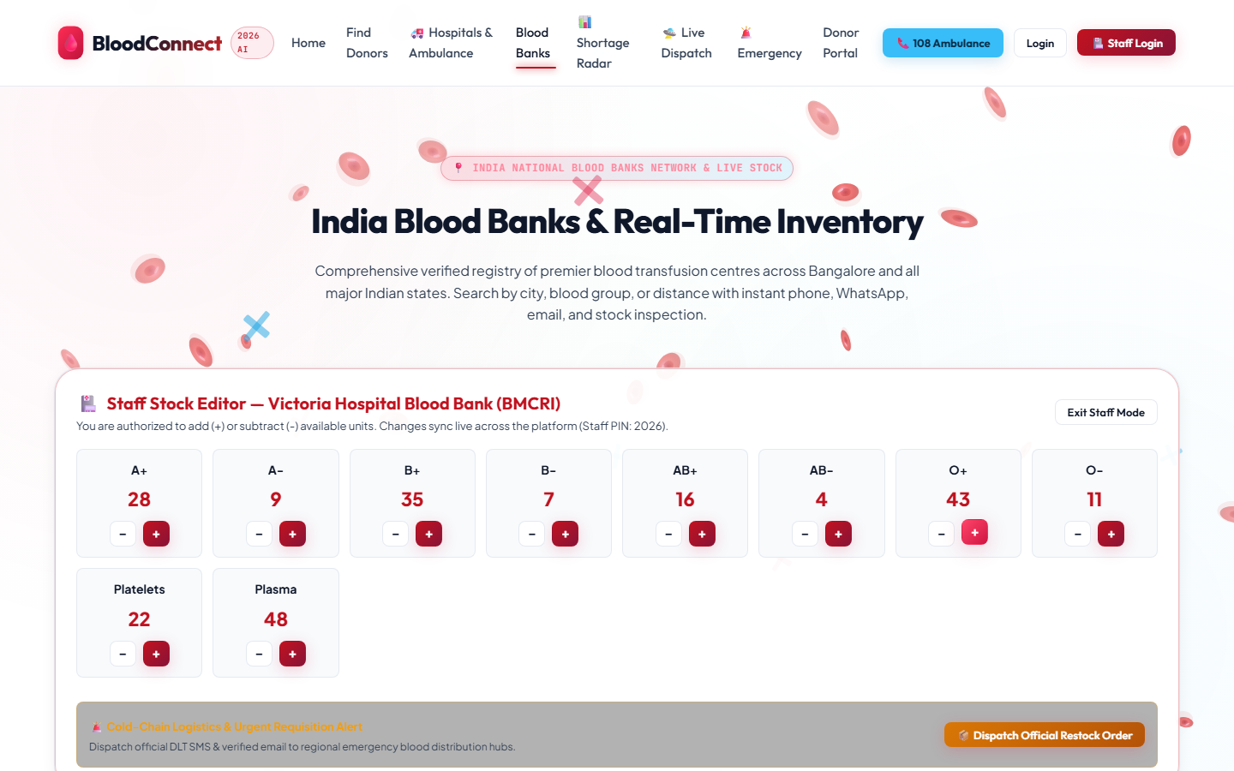
Fig. 4.6 Blood-centre stock view
Processing of a match is deterministic. Given the same donors and the same request coordinates, the order does not depend on a hidden model file. The eligibility function returns reasons in sentences, for example that the minimum age is 18 years or that a number of days remain in the 90-day interval. A haemoglobin value is checked only when the caller supplies it, because the prototype must not invent a laboratory result. First-time donors aged 60 to 65 receive a warning rather than a silent pass, asking for on-site medical review.
The shortage function used by the page totals units of each group across the loaded centres and marks the group as critical, low or adequate against fixed thresholds. A second view uses a prepared seven-day scenario in which some groups, including O negative and platelets, are shown in deficit. That scenario is labelled by its status fields so a reviewer can see it is a teaching case for monsoon and trauma pressure, not a fitted time series. Building a real forecast remains future work and needs centre permission and historical issue data.
A dispatch page can illustrate movement on a map for a demonstration. It is not connected to an ambulance service and it does not control a vehicle. Any drone or airway animation in the demonstration data is a picture of a possible corridor, not an operational system, and it is outside the claim of this report.
4.3 Tools, Technologies and Resources
The browser pages use the web platform only, so a review laptop does not need a framework install to open them. The service uses Spring Boot for HTTP, validation and security filters, and JUnit for the automated checks. Persistence is H2 when the local profile is used, which keeps a classroom demonstration independent of a shared database password. The MySQL script is present for a deployment in which data should survive a restart. Email and SMS delivery of one-time passwords are designed behind a provider configuration. If the provider keys are absent, the service is not described as having delivered a real message.
Resources that were intentionally not required include a GPU, a paid map key for the core match, and a hospital information-system login. Map tiles on the tracking demonstration are a display aid. The distance that affects rank is computed by the formula in the matcher, so the scientific part of the project does not depend on a tile server being reachable during the viva.
4.4 Implementation Evidence and Progress
Evidence of implementation is the set of pages in Figs. 4.1 to 4.6, the service classes for authentication, donors, requests, matching and blood banks, and the test class that locks the compatibility table. A reviewer can register two roles, create a donor profile, create a request and request matches, using the local profile. Public registration cannot create an administrator. An administrator, when configured through the environment rather than through a password committed in a file, can see account email, role and time of creation, and cannot see a password.
Progress against the objectives in Section 1.5 is as follows. The request path, the red-cell filter, the distance ranking, the eligibility screen, the directories, the shortage view and the verification design are present in the prototype. The survey instrument is present and is described in Chapter 5. A supervised pilot inside a blood centre, with real stock and real consent, has not been done and is not claimed.

CHAPTER 5
TESTING, VALIDATION AND RESULTS
5.1 Validation Plan
Validation was planned around mistakes that would hurt a person if the software made them, not around cosmetic page checks. The mistakes that matter are offering an incompatible group, ranking a far exact match above a near exact match without saying why, treating a recently donated person as ready, and speaking as if the tool had issued blood. The plan has three layers.
The first layer is a hand-checkable table, Table 3.1, implemented once and exercised by parameterized tests for every recipient and donor pair that the team considered easy to get wrong, including the illegal pair of an AB negative recipient with an AB positive red-cell donor. The second layer is an ordering test: several available donors are presented to the matcher, an incompatible donor is included on purpose, and the returned names and distances must follow distance, then score, then name. The third layer is the eligibility and spam rules on the page, checked against the sentences the function returns. A fourth, separate layer is the survey, which validates the problem statement with people rather than validating the formula.
5.2 Test Cases and Evaluation Criteria
A test passes only when the observable result matches the rule. “The page loaded” is not a pass for this project. Table 5.1 lists the checks that define success.
Table 5.1 Checks used to validate matching and eligibility
ID | Input situation | Expected result | Why it matters
TC01 | Recipient O−, donor O+ | Donor excluded | The common universal-donor mistake
TC02 | Recipient O−, donor O− | Donor retained | The only legal red-cell donor for O−
TC03 | Recipient A+, donor B+ | Donor excluded | Stops a same-Rh but wrong-ABO unit
TC04 | Recipient AB+, donor O− | Donor retained | AB+ can receive red cells from any group
TC05 | Recipient AB−, donor AB+ | Donor excluded | Rh is part of the rule, not a detail
TC06 | A+ request with a nearer A+ donor and a farther A+ donor | Nearer donor first | Distance is the first sort key
TC07 | Compatible donor with no coordinates | Listed after donors that have distance | Missing location must not jump the queue
TC08 | Age 17, or weight 44 kg | Not eligible, with a reason | Protects the donor
TC09 | Last donation 30 days ago | Not eligible; days remaining shown | Enforces the recovery interval
TC10 | Haemoglobin 11.0 g/dL when supplied | Not eligible | Does not invent a lab value, but honours one
TC11 | Very large unit count or a hospital name that is an obvious test | Flagged for review | Reduces panic and fake requests

The service test for ordering uses an A positive request and a mixture of A positive donors, an O negative donor, a B positive donor and a donor without coordinates. The B positive donor is absent from the result. Donors at the same near location are ordered by name after the score comparison, and the donor without coordinates is last. Reported distances in that test are about 11.1 km for the near cluster and about 111.2 km for the far donor, which matches the Haversine calculation on the coordinates chosen for the test. That gives a reviewer a number to recompute.
5.3 Results and Analysis
The compatibility tests cover the pairs encoded for O, A, B and AB, both Rh types, including pairs that must fail. The implementation returned the expected Boolean for those pairs. This result supports the claim that the matcher and Table 3.1 are the same rule. It does not support a claim about plasma, granulocytes or emergency uncrossmatched policy inside a trauma bay. Those decisions stay with the clinician.
The ordering result supports a smaller claim that is still socially useful. When two donors are legally acceptable, the nearer one is not buried under an arbitrary list. When location is missing, the software does not pretend to know a distance. Families can be told that a blank distance means “place not shared”, which is more honest than a fabricated kilometre value.
Table 5.2 applies the service score to three imaginary donors for an A positive recipient so the arithmetic can be read without opening the code. Availability contributes 20. An exact group contributes 50 and a compatible non-exact group contributes 30. A distance term contributes 30 minus the rounded kilometres, and not less than zero. The people are not real and must not be contacted.
Table 5.2 Worked example of the priority score on imaginary donors
Imaginary donor | Group | Distance (km) | Score calculation | Score
Donor A | A+ | 3 | 20 + 50 + (30 − 3) | 97
Donor B | O+ | 3 | 20 + 30 + (30 − 3) | 77
Donor C | A+ | 8 | 20 + 50 + (30 − 8) | 92

Donor A ranks above Donor C because the extra kilometres cost more than nothing, and above Donor B because an exact group is preferred when distance is equal. Donor B remains visible because O positive red cells are acceptable for A positive, but the list does not hide the fact that the group is not exact. If the recipient were O negative, Donor A and Donor B would disappear even if they stood closer than an O negative donor. That single behaviour is the main safety result of the project.
Eligibility results are similarly direct. A missing age or weight fails closed. A haemoglobin field left empty does not fail and does not pass a laboratory test; it is simply unknown. A donation date 30 days in the past produces a positive number of days remaining and an ineligible result. These outcomes match the sentences written in Section 3.5.
5.4 Stakeholder and User Feedback
A public survey was prepared for Bengaluru and Karnataka respondents. It takes about six minutes, states that it is a student societal project, and states that submitting the form is not a blood request. The name is optional. Seventeen items cover who the respondent is, whether the family has needed blood in five years, how it was found, how long the first unit took, how hard the search felt, whether the respondent has donated, what blocks donation, whether the 90-day interval is known, whether they would register to be called only for a nearby compatible patient, how useful ranking and a directory seem, what they fear about such a system, and who should operate it. The full item list is Annexure A.
This report does not invent percentages from that form. Responses, when collected, stay out of the printed chapters if they contain a name or a family story. The indicators to be filled after fieldwork, and then only as aggregates, are: the share who found blood through calls or social media, the share who rated the search hard, the share willing to be contacted for a nearby compatible patient, and the most common trust concern. Until those aggregates exist, stakeholder evidence in this document is the design of the instrument and the match between its questions and the problem statement in Section 1.4.
Informal expectations were still used as design input. A donor-side concern is being woken for the wrong group. The compatibility filter is the response to that concern. A family-side concern is not knowing which centre to try. The directory is the response. A clinician-side concern is a student application that sounds like a blood bank. The disclaimer and the decision not to return a donor phone number on the service match are the response.
5.5 Limitations
The prototype has limits that should be said in the review before they are asked.
• No clinical trial and no count of minutes saved in a real ward.
• Demonstration stock, donors and shortage scenarios are not live centre data.
• The response percentage is a formula, not a model trained on who actually arrived.
• Keyword triage can be fooled by wording and does not read a case sheet.
• Straight-line distance is not travel time in Bengaluru traffic.
• The eligibility screen is a subset of donor selection, not a medical examination.
• One-time password delivery depends on provider configuration and was not treated as proved without that configuration.
• A shared demonstration control for editing stock is not an acceptable access method for a real inventory.
• The survey has not yet been reported here as a completed field sample.

CHAPTER 6
SOCIETAL IMPACT, SUSTAINABILITY AND SDG CONTRIBUTION
6.1 Societal Impact and Beneficiary Outcomes
The impact claimed for this stage is a change in how the first search is organised, not a change in mortality. If a family uses the prototype as intended, three harmful habits become less likely. The first is messaging every group in the hope that someone knows an O negative donor. The second is treating a willing classmate as eligible without asking when they last donated. The third is assuming that a website badge has replaced the blood centre. Avoiding those habits is a real outcome even before a city-wide deployment.
Donors benefit if the system keeps them from being asked to do something unsafe. Centres benefit if fewer calls are spent explaining basic compatibility that a table could have filtered. Students and the department benefit if the project shows AI used as an explanation tool on a public problem, with the limit of the data written down. Patients benefit only indirectly, and only if the clearer search leads the family to a legal unit sooner. That last link is plausible and unmeasured. It is recorded as an expected outcome.
6.2 SDG Mapping and Evidence
Table 6.1 repeats the mapping from the front of the report and ties each goal to something a reviewer can open. Goals without that property were left out.
Table 6.1 SDG contribution and the evidence retained with the project
SDG | Contribution in this project | Evidence that can be shown
3 Good Health and Well-being | Safer first search: compatible donors only, recovery interval, and a path toward a centre | Table 3.1, eligibility reasons, disclaimer text, Figs. 4.3 and 4.4
9 Industry, Innovation and Infrastructure | A maintainable browser-and-service tool rather than a one-off poster | Running pages and service tests described in Chapters 4 and 5
10 Reduced Inequalities | The directory and request do not require the user to already belong to a donor network | Figs. 4.5 and 4.6 and survey items on how blood was found

Goal 3 is the primary link. The project does not deliver clinical care. It supports the conditions for care by reducing a known form of delay and a known form of donor harm. Goal 9 is met at prototype scale: the artefact can be run, explained and extended. Goal 10 is met in intention and in interface design. It would be met in outcome only after people without existing hospital contacts actually use the tool. That is why the survey asks how blood was found, instead of assuming the answer.
6.3 Feasibility, Accessibility, Cost and Sustainability
Feasibility for a semester project is demonstrated by the fact that the match does not need a hospital contract to be tested. The rules run on synthetic profiles. Feasibility for a public service is a different question. It would need a centre willing to own the data, a consent path for donors, a Kannada and English interface, and an operator who disables the tool rather than showing stale stock. Those conditions are future work, and they are cheaper to discover now than after a false public launch.
Accessibility was considered in the page structure. The emergency action is available from the home page, buttons are large enough for a thumb, and the survey can be completed without giving a name. A remaining gap is language. The interface is in English. In Bengaluru that excludes some of the relatives who do the searching. Kannada text is a practical next increment, not a decoration.
Cost to the end user in the student version is the cost of a data connection. There is no fee in the prototype. Hosting for a college demonstration fits on a single machine. The expensive resources are the ones the project refuses to consume: clinician time spent correcting a bad list, and donor goodwill spent on the wrong calls. Sustainability of the idea depends on keeping the compatibility table and the disclaimer intact when features are added. A later team can replace the shortage scenario with real data without rewriting the ethical boundary.

CHAPTER 7
CONCLUSION AND FUTURE SCOPE
BloodConnect was built to make the first hour of an emergency blood search in Bengaluru less confused and less unsafe. The prototype accepts a request, applies a red-cell ABO and Rh table, ranks available compatible donors by distance and an explainable score, screens donors for age, weight, haemoglobin when supplied and a 90-day interval, and places hospital and blood-centre information beside that list. Account verification is designed so that a new user signs in only after email and phone codes are confirmed. Tests lock the compatibility pairs and the ordering behaviour. A 17-item survey is ready for field responses.
The project meets its societal aim at prototype scale. It does not meet, and does not claim, the aim of issuing blood or of proving a reduction in deaths. The useful academic result is the boundary: an AI-related score is used only where the inputs are visible, national systems such as e-RaktKosh are acknowledged, and the medical act is left with the licensed centre.
Future work, in a sensible order, is as follows. Administer the survey and report only aggregates. Add Kannada labels on the request and eligibility messages. Replace demonstration stock with a read-only feed from a centre that has agreed to it. Keep donor contact behind an explicit accept action. Fit a shortage forecast only after historical issue data exists; until then, do not describe the scenario screen as a trained model. Pilot with one voluntary donation camp linked to the department, where eligibility reminders can be checked by the camp’s medical officer. Any step that touches a real donor identity needs consent, a data register and faculty approval before it is built.

REFERENCES

[1] A. M. Ghouri, H. R. Khan, V. Mani, M. A. U. Haq, and A. B. L. de Sousa Jabbour, “An artificial-intelligence-based omnichannel blood supply chain: A pathway for sustainable development,” Journal of Business Research, vol. 164, p. 113980, 2023, doi: 10.1016/j.jbusres.2023.113980.
[2] M. Shokouhifar and M. Ranjbarimesan, “Multivariate time-series blood donation/demand forecasting for resilient supply chain management during COVID-19 pandemic,” Cleaner Logistics and Supply Chain, vol. 5, p. 100078, 2022, doi: 10.1016/j.clscn.2022.100078.
[3] A. B. James, C. D. Josephson, B. H. Shaz, G. B. Schreiber, C. D. Hillyer, and J. D. Roback, “The value of area-based analyses of donation patterns for recruitment strategies,” Transfusion, vol. 54, no. 12, pp. 3051–3060, 2014, doi: 10.1111/trf.12740.
[4] G. Urs, A. Miyajiwala, A. Raj, and S. Zadey, “Timely geographic access to blood banking facilities: A pan-India modelling study,” Transfusion Medicine, vol. 36, no. 4, pp. 360–369, 2026, doi: 10.1111/tme.70075.
[5] “Real-Time Blood Donor Prediction and Campaign Optimization using DNN-Autoencoder and MERN Architecture,” in Proceedings of the 3rd International Conference on Self Sustainable Artificial Intelligence Systems (ICSSAS), 2025, doi: 10.1109/ICSSA66150.2025.11080959.
.
ANNEXURES
Annexure A Public survey instrument
The form is titled “BloodConnect — Emergency Blood Access”. It states the place as Bengaluru or Karnataka, the time as about six minutes, and that the name is optional. The respondent must accept that the survey is for a student project, that it is not a real blood request, and that no medical record has been entered. Items are summarised in Table A.1. Wording on the form should be kept when the annexure is printed for a review, so that the consent line remains visible.
Table A.1 Items in the public survey instrument
Item | What it asks
1 | Name, optional
2 | Area or city
3 | Age group
4 | Role, such as student, donor, family member or health worker
5 | Whether anyone in the family needed blood urgently in the last five years
6 | How blood was found, if it was needed
7 | Approximate time to arrange the first unit
8 | How hard the search felt
9 | Whether the respondent has donated
10 | What holds the respondent back, if they have not donated recently
11 | Whether they knew about the interval of about 90 days
12 | Willingness to register if contacted only for a compatible patient nearby
13 | Usefulness of ranking nearby compatible donors
14 | Usefulness of a hospital and blood-centre directory with stock counts
15 | Biggest concern about a system of this kind
16 | Who should operate the service
17 | One change that would increase trust or use

Annexure B Demonstration data and what must not be copied into a viva as fact
Profiles loaded for screenshots and for the shortage scenario are fictional. They are not donors of any hospital, and the telephone numbers and email addresses in that file must not be dialled, mailed or pasted into this report. Masked identity strings in the same file are not Aadhaar numbers and must not be replaced with real ones. Stock counts illustrate layout and threshold logic. A sentence in the review such as “Victoria Hospital has this many units today” is not supported by the project data.
Annexure C Main pages available in the prototype
• Home page, with the public explanation and the emergency path.
• Registration and login, including the verification step required by the service.
• Emergency request and matching results.
• Donor directory and donor dashboard.
• Hospital directory and blood-centre stock view.
• Shortage radar based on totals and on the prepared scenario.
• Dispatch demonstration page, which is illustrative and is not an ambulance connection.
• About page, including the clinical disclaimer.
• Administrator view for audit-style information that does not include passwords.
Sample accounts, if used in a demonstration, should be taken from the team’s private test note and spoken in the room. They are not printed here, so that a submitted report is not also a list of passwords.

